Knowbility John Slatin AccessU 2016

Accessible WordPress Content, Session Outline

Hands-on with WordPress
During this hands-on session you will log in to your WordPress site as an administrator and discover how to add accessible content. We will explore your themes and ways you can improve accessibility with plugins, widgets, and a little pixie dust.

Action 0: add semantic links
Semantic links are links that make sense when isolated in lists. Screen reader users have the abiliity to do this. When links are read in this fashion, will they convey the information you want?

Action 1: add a skip link and more with WP Accessibility plugin
Do you know what a skip-link does, why it's needed, and how to easily add one to your WordPress theme? What's wrong with those "Continue reading" links where you've inserted the "more” tag and what can you do about it? We will explore WP Accessibility by Joe Dolson and discuss the issues it corrects.

Action 2: add alternative text descriptions to media
Confused by the difference between captions, alternative text, and descriptions in the WordPress Add Media process? Editing media file captions and alternative text using the Media Library admin screens is next.

Action 3: use of headings and lists
Then it's on to how to find out which heading levels pre-exist in your theme and proper use of heading levels and we will explore lists.

Action 4: Add New Post
We'll use the Add New Post admin screen to add a new post, examining the difference between Visual and Text editing. While we're in the Add New Post screen we'll take the time to explore the WYSIWYG editor, TinyMCE.

Action 5: Testing with simple tools
We'll finish up with some easily used tools for testing your work.

Action 0: add semantic links

What is a semantic link?
Linguistic semantics is the study of meaning that is used for understanding human expression through language. The term “Semantic Web” refers to W3C’s vision of the Web of linked data. Semantic Web technologies enable people to create data stores on the Web, build vocabularies, and write rules for handling data. You can choose use HTML to make all your buttons or you can make them from Javascript. Without doing some extra coding to make Javascript buttons work for Assistive Technology users they might not work at all. An HTML button in a screen reader is annunciated as "button" because it has native semantics.

Here's an example of someone using Dragon Naturally speaking and what he finds out about non-semantic coding.

There are at least two parts to a link: the link text and the URL. The link text is the semantic representation of the destination, the URL. While it is possible to make links with very short link text it really is better if you describe the destination more fully. This has an added benefit to users of AT who can isolate lists of items on a page such as headings, lists, and links. Making the link text meaningful helps AT users navigate. If you make all your link text "here" for example, AT users will wind up with a list of links that all read the same. Not very helpful.

This also applies to the "read more," or "continue reading" links at the jump. Winding up with a bunch of links that say read more, read more, read more, is not very helpful. Those links should also include the title of the post to be useful to everyone. You can either use a theme that incorporates the title into the "continue reading" links, or you can use Joe Dolson's WP Accessibility plugin.

Action 1: add a skip link and more with WP Accessibility plugin

What does a skip-link do?
Do you know what a skip-link does, why it's needed, and how to easily add one to your WordPress theme? WCAG 2.0 section 2.4.1, Bypass Blocks, suggests that we provide a mechanism for bypassing blocks of content such as navigation links, heading graphics, and advertising frames. Instead of asking keyboard users to tab through every item in a navigation menu system on every one of our pages we need to make it easy for them to bypass those links. In years past we called this "skipnav" since it skipped navigation. Now we're calling it skip to content, a more positive and semantic phrasing. If you ask the average web user to skip the navigation they might not know what you mean, but if you ask them to skip to the content they will be more likely to have a good idea of where they are headed.

Setting the skip link
Just setting an anchor link is not enough. That will move the cursor to the anchor point such as the main content area, but it won't move the focus in all browsers. To move the focus you need some JavaScript. Fortunately for those of us who don't know JavaScript, there's a plugin for that! The plugin you need is WP Accessibility Plugin, by Joe Dolson. It's available in the plugin directory, search for "WP Accessibility."

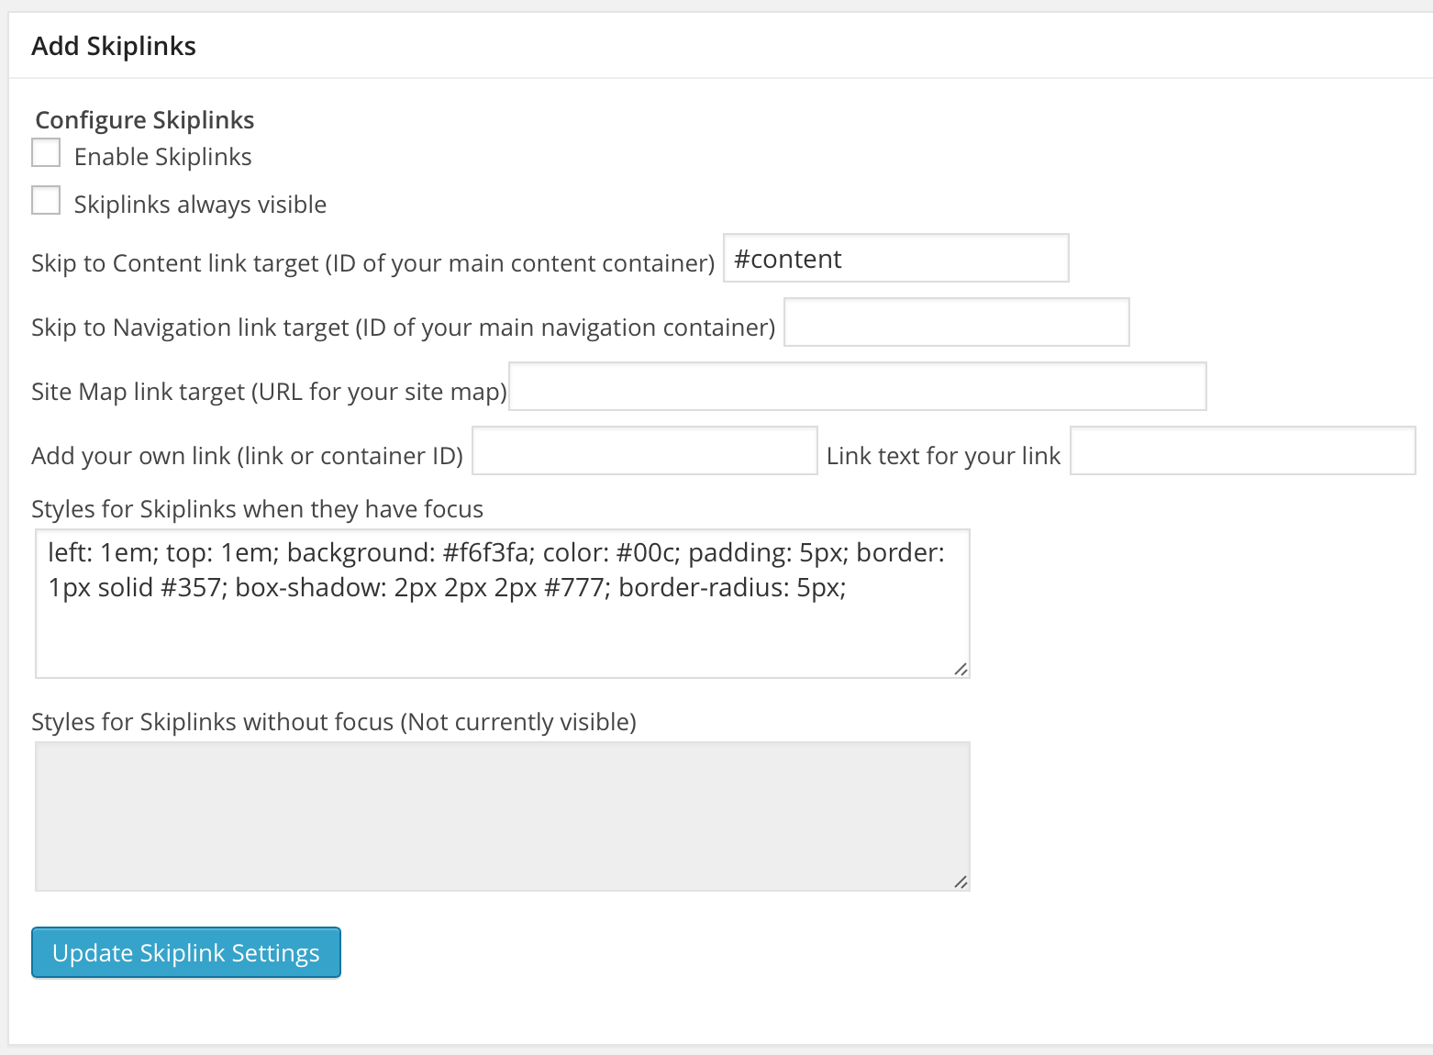
Joe Dolson's WP Accessibility plugin controls showing only the skiplinks configuration options.

There is a second recommended skip link plugin, the SkipTo plugin by the PayPal Accessibility Team, it only does skip links and not a range of other things, but if all you need is skip links then Skip To is great.

Many other features of WP Accessibility
There are many other excellent features of WP Accessibility and we will explore some of them if we have time. Please read about the accessibility issues corrected by WP Accessibility and explore the settings.

Action 2: add alternative text descriptions to media
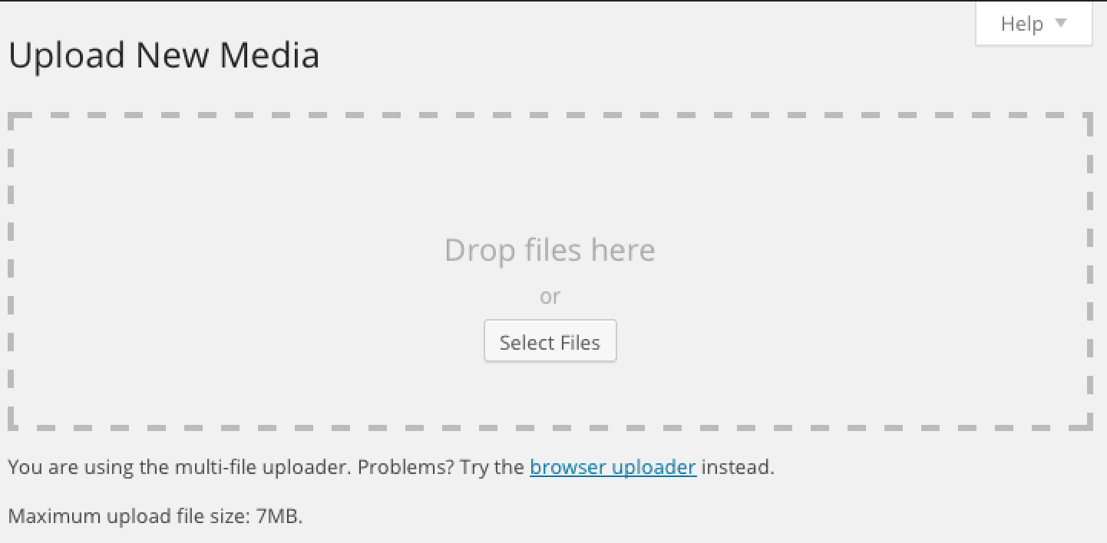
WordPress Add New Media multi-file uploader screen.

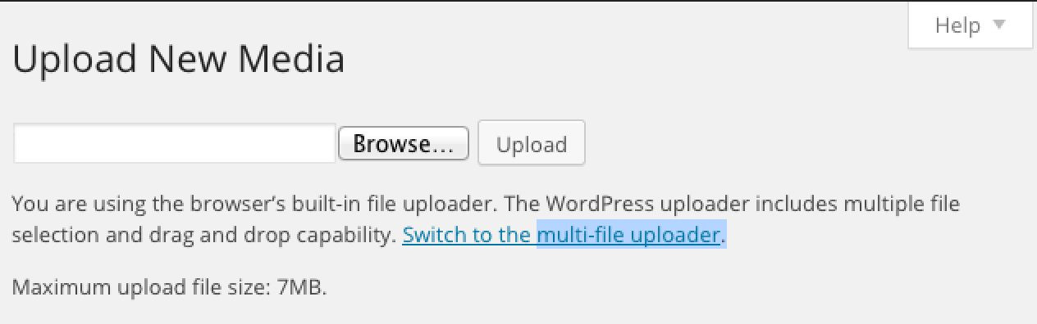
WordPress Add New Media browser uploader screen.

Adding new media
The multi-file uploader screen is presented first. At the bottom of that screen is a control to switch to the browser uploader screen. If you don't need to load multiple files at the same time or can't use drag and drop or you simply yearn for the days of yesteryear then you'll want the browser uploader screen which is simply a data entry field, a browse button to locate the image file in your local file system, and an upload button which is activated once you have chosen the image. Presenting only a drag and drop interface would present an accessibility issue and the developers have provided an alternate screen to make access possible for everyone. Once you have chosen the file you want to upload then you're ready to use the next screen, the Media Library screen.

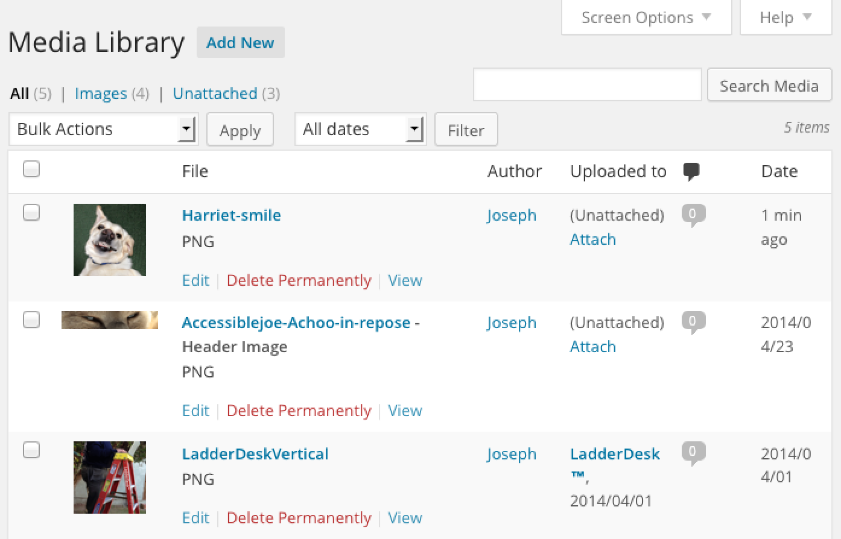
WordPress Media Library Screen

Changing title; adding caption, alt text, and description
All HTML images must be associated with an alt attribute, the text alternative to the graphic content which is commonly referred to as “alt text.” Background images that are created using CSS cannot receive an alt attribute and so should be used only for decorative images that have no other significance or function.
- If image is active (image link, image button, image map area), then the text alternative should be the function of the image, what the image does, where the link goes.
- If image is text, then the alt text should (usually) be the same as the text in the image.
- If image conveys information, the alt text should convey the same information
- If image is complex as they are in maps, graphs, and charts, use a technique to convey the complete meaning. Some possibilities are to provide on-screen a full explanation; access to data that generated the chart, or longdesc link.
- If the image is only for decorative purposes, or is redundant to adjacent text, use alt=””
- If active image uses empty alt, it MUST be wrapped in the same anchor as descriptive text.

Action 3: use of headings and lists
Proper use of heading levels is an important part of content creation. Do break up your content with subheads. Don't write long blocks of text without subheads. Headings provide navigational cues for all users, especially Assistive Technology (AT) users. It is partly up to the content creator to assign heading levels. Theme designers and developers also set heading levels. Heading levels need to be logical and flow from heading level one through heading level six if needed.

Don't use headings for layout
You should use only one heading level one <h1> per page (not per post), followed by h2 through h6 as needed. Never use heading levels for layout purposes. An example of using a heading level for layout is: "I like the way h4 looks so I'll just use that everywhere." Now that HTML5 has released specs that allow for the use of multiple h1s on a page we will see themes with an h1 for each post title. If you can't change that, work with it the best you can.

How headings help AT
AT can be used to separate out headings, links, lists, and other items. Just as some might rely on a visual scan of a page to zero in on specific information, screen reader users use isolated lists of headings, links, lists, and other items for navigation. Setting a good hierarchy of heading levels on a page assists this navigation.

Know your heading levels
I recommend using Jim Thatcher's Favelets for Checking Web Accessibility with Firefox for an instant view of the existing heading levels in your theme structure. Once you know if your post title heading is h1 or h2 you should be able to assign other heading levels in a logical manner. If you have a post you know has a title with an h2, then use an h3, h4, etc. for content headings.

Example:
<h2>Knowbility AccessU Today</h2> (post title)
<h3>What's Happening Right Now</h3> (first subhead)
At this very moment we're in the Accessible WordPress Content session learning about heading levels. Use heading levels in order. Just don't use heading levels as layout elements "because they look the way I want them to." (paragraph)

Don't Use Bold Text As Heading
The following graphic is a screenshot of a heading on austin.com. At least it looks like a heading. It's bold and there's a space between it and the next line:
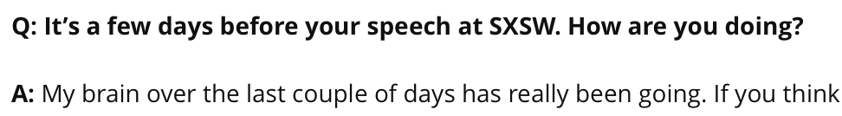

Code:
<p><strong>Q: It’s a few days before your speech at SXSW. How are you doing? </strong></p>
<p><strong>A:</strong> My brain over the last couple of days has really been going. If you think…

Looking at the code, though, reveals that it is not a heading, just some bolded text. Headings give assistive technology users information they can use. Bold text does not. Screen reader users, for example, can generate lists of headings and go to the heading they choose, much like other users can scan a page and start reading at the heading they want.

Lists
Heading levels are one way to give semantic meaning and create hooks for AT. Another item you want to pay attention to is lists.

I could use the keyboard combination for bullet, type in the list item, hit return after each item:
• item one
• item two
• item three
but this construction does nothing for semantics and it doesn't provide information usable by AT.

Instead, you should use the list code for unordered list <ul>, ordered list <ol>, and description list <dl> to produce a list. Here we have an unordered list which will result in a bulleted list:

<ul>
<li>item one</li>
<li>item two</li>
<li>item three</li>
</ul>

it will look about the same as the non-semantic "looks like a list" technique
- item one
- item two
- item three
but it will be announced as a list to AT.

Text vs Visual tabs
Using the Text tab and learning the simple HTML to create lists is easy, or you can use the Visual tab in the Add New Post screen to select the text you want made into a list and use one of the list buttons in the WYSIWYG editor, TinyMCE, to format the list for you. To use TinyMCE with AT there are some resources available such as this information about using TinyMCE with NVDA and Firefox from Marco Zehe on the TinyMCE Wiki.

Action 4: Add New Post

Text tab
You can use the Visual tab in the Add New Post screen and maybe never see the code, but I find that for accuracy and troubleshooting, learning some simple HTML code pays off in the long run. Ever apply a style in the Visual edit tab only to have a large block of following text suddenly look like a heading level? It happens, and you'll need to use the Text tab to find the error and correct it. Some people use tools to markup or markdown their writing and just paste it into WordPress. I do it all in WordPress.

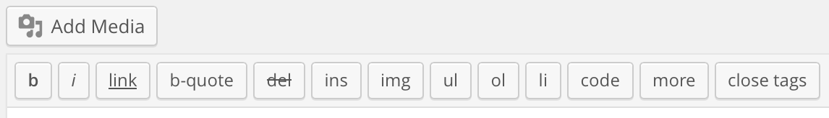
Text tab selected, showing controls.

- b - <strong></strong> HTML tag for strong emphasis of text (i.e. bold).
- i - <em></em> HTML tag for emphasis of text (i.e. italicize).
- link - <a href="http://example.com"></a> HTML tag to create a hyperlink.
- b-quote - <blockquote></blockquote> HTML tag to distinguish quoted or cited text.
- del - <del></del> HTML tag to label text considered deleted from a post. Most browsers display as strike-through text. (Assigns datetime attribute with offset from GMT (UTC))
- ins - <ins></ins> HTML tag to label text considered inserted into a post. Most browsers display as underlined text. (Assigns datetime attribute with offset from GMT (UTC))
- ul - <ul></ul> HTML tag will insert an unordered list, or wrap the selected text in same. An unordered list will typically be a bulleted list of items.
- ol - <ol></ol> HTML tag will insert a numbered list, or wrap the selected text in same. Each of the items in an ordered list are typically numbered.
- li - <li></li> HTML tag will insert or make the selected text a list item. Used in conjunction with the ul or ol tag.
- code - <code></code> HTML tag for preformatted styling of text. Generally sets text in a monospaced font, such as Courier.
- more - <!--more--> WordPress tag that breaks a post into "teaser" and content sections. Type a few paragraphs, insert this tag, then compose the rest of your post. On your blog's home page you'll see only those first paragraphs with a hyperlink ((more...)), which, when followed, displays the rest of the post's content.
- Close Tags - Closes any open HTML tags left open but pay attention to the closing tags, make sure the tags enclose what you want, and in the proper way.

WYSIWYG editor, TinyMCE
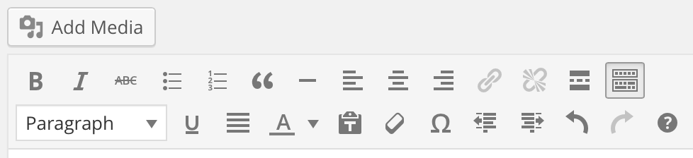
Visual tab selected showing controls.

First row:
- b - <strong></strong> HTML tag for strong emphasis of text (i.e. bold).
- I - <em></em> HTML tag for emphasis of text (i.e. italicize).
- del - <del></del> HTML tag to label text considered deleted from a post. Most browsers display as strike-through text. (Assigns datetime attribute with offset from GMT (UTC))
- ul - <ul></ul> HTML tag will insert an unordered list, or wrap the selected text in same. An unordered list will typically be a bulleted list of items.
- ol - <ol></ol> HTML tag will insert a numbered list, or wrap the selected text in same. Each item in an ordered list is typically numbered.
- b-quote - <blockquote></blockquote> HTML tag to distinguish quoted or cited text.
- − insert graphic line (rule)
- left justify
- center justify
- right justify
- link - <a href="http://example.com">link name</a> HTML tag to create a hyperlink.
- undo link
- more - <!--more--> WordPress tag that breaks a post into "teaser" and content sections. Type a few paragraphs, insert this tag, then compose the rest of your post. On your blog's home page you'll see only those first paragraphs with a hyperlink ((more...)), which when followed displays the rest of the post's content.
- toggle toolbar show/hide second row of controls

Second row:
- styles – paragraph, address, pre, heading 1 – 6
- underline
- justify
- text color
- paste as text – removes markup
- clear formatting
- special character
- decrease indent
- increase indent
- undo
- redo
- keyboard shortcuts

Action 5: Testing with simple tools
We'll finish up by exploring some easily used tools for testing your work.

Resources:

How to Disable Image Attachment Pages in WordPress
Tanaguru Contrast-Finder
DIY Captioning
Gartner Says Companies Should Deploy Technologies to Address IT Accessibility
How To Set Up An Accessible Form Using Contact Form 7 In Wordpress
WordPress Plugin: BotSmasher by Joe Dolson
How to Make Gravity Forms and Contact Form 7 Forms More Accessible in WordPress
Practical ARIA Examples
Short Mobile Accessibility Checklist
Website Accessibility and WordPress
Zebra Striping: Does it Really Help?
Zebra Striping: More Data for the Case
Aaron Jorbin, AccessU 2014, Understanding Color
Aaron Jorbin, Color Test
WordPress Admin Pages
This is a list of the admin pages in WordPress trunk:

Toolbar Across Top

(NB: hamburger menu icon  visible on small screens.)
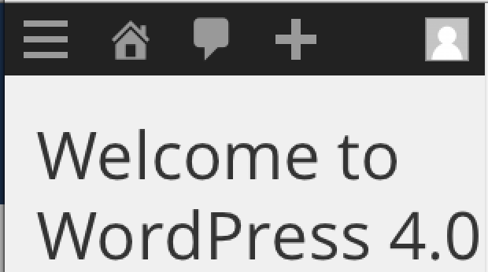

WordPress (Icon)
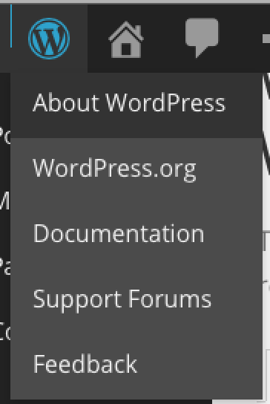
- About WordPress
- WordPress.org (external)
- Documentation (external)
- Support Forums (external)
- Feedback (external)

Home (Icon) – (with site name: Nightly build)
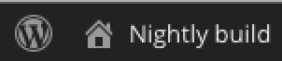
- Visit Site

Comments Awaiting Moderation (Icon) 

Plus (Icon) – Add New 
- Post
- Media
- Page
- User

Howdy, (name of person logged in)

- Name of Person Logged In
- Edit My Profile
- Log Out (logs out, goes to log in page)

Dashboard (down the left side)
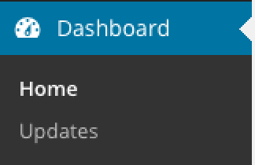
- Home
- Updates

Posts
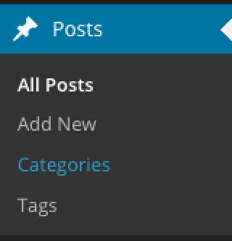
- All Posts
- Add New
- Categories
- Tags

Media
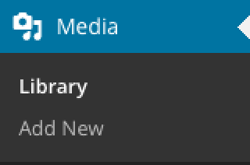
- Library
- Add New

Pages
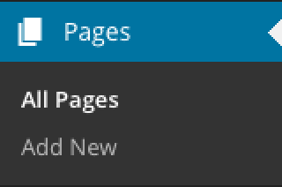
- All Pages
- Add New

Comments (single page)

Appearance
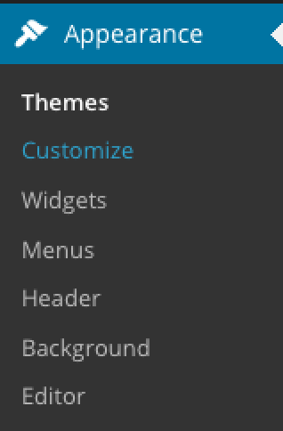
- Themes
- Customize
- Widgets
- Menus
- Header
- Background
- Editor

Plugins
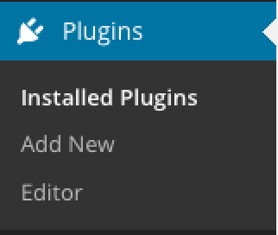
- Installed Plugins
- Add New
- Editor

Users
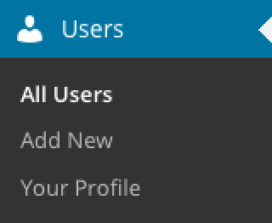
- All Users
- Add New
- Your Profile

Tools
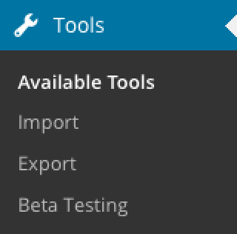
- Available Tools
- Import
- Export
- Beta Testing (specific to WordPress Beta Testing plugin)

Settings
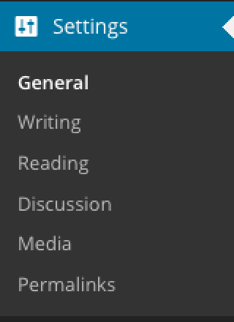
- General
- Writing
- Reading
- Discussion
- Media
- Permalinks

